Chapter 9, Problem 68.

Determine Y_{eq} for the circuit in Fig. 9.75.

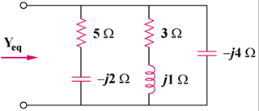

Figure 9.75
For Prob. 9.68.

